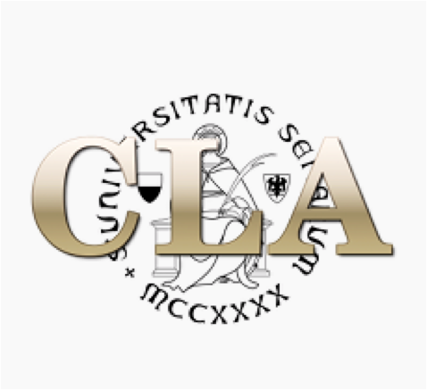

________

CLA Seminars

CONTENT, ORGANIZATION AND STRATEGIES FOR THE
B2 LEVEL ENGLISH EXAM

STUDENTS WHO DID NOT TAKE A COURSE AT THE CLA
AND WHO ARE REGISTERED FOR THE EXAM ON 20 JANUARY
ARE STRONGLY ENCOURAGED TO ATTEND

FRIDAY 20 JANUARY
TIME: 12.00 TO 14:00
ROOM 3 - PIAZZA SAN FRANCESCO, 7 – SIENA
dr.ssa Janet Donovan

DOWNLOAD AND PRINT THE FILE AT THE FOLLOWING LINK AND
BRING IT WITH YOU TO THE SEMINAR:
DOWNLOAD SEMINAR MATERIALS
(available on the website of the Centro Linguistico)

The seminar will include a detailed explanation of the two tests that make up the
B2 Level English exam: the Reading Test and the Use of English Test.
Exam strategies will also be covered.

